

Year in Review - 2023

Cyprus Real Estate Market

February 2024



**4**

**Foreword**

**3**

Table of Contents

**FY 2023**

**The key highlights**

**7**

**Cyprus economy update**

**33**

**Foreign transaction activity**

**15**

Transaction volumes/ Investment activity levels

**37**

**High-end residential**

property segment (≥ €1,5mln)

**18**

**District Snapshots**

**39**

**Real estate price evolution**

**41**



**Construction activity**

**45**

**PwC Real Estate Advisory Services**

**49**

**PwC in Cyprus**

## Foreword

We are delighted to present our latest PwC Cyprus Real Estate Market publication. This publication provides information about the Cyprus economy in general and an analysis of key real estate market developments, focusing on the performance of the sector during

**2023. Our analysis includes presentation of transaction activity exhibited across the island, the residential property sector in particular, the behaviour of property prices and developments in the construction sector. The analysis presented**

is based on the available market data for 2023, using PwC’s rich and in-depth market expertise and data analytics capabilities.

Our world is in a state of polycrisis and our businesses are battling with strong headwinds in the form of economic instability, geopolitical tensions, polarized societies and media, increased regulatory complexity etc. Even more important, the disruption brought about by generative AI and climate change pose existential threats to businesses, challenging their very viability over the next few years.



Despite the difficult environment, sustainable prosperity and economic growth is possible but only if we embrace technological advancements and transform our business and operating models accordingly. To thrive in today’s world, organizations need to reinvent themselves

and change how they create, deliver and capture economic value. As leaders, we need to re-imagine and transform our organizations and avoid the risk of applying a short-term, crisis management mindset.

In Cyprus, we have good reasons to be optimistic about our future. The Cyprus economy has been particularly resilient to external shocks and it is expected to record a positive GDP growth of 2,2% during 2023. It is clear that the small size of our economy and our extroverted nature continue to provide us with agility and bounce- back possibilities. Cyprus’ Vision 2035 provides the direction and the platform for the cultural as well as structural changes needed to mobilize the entire Cypriot ecosystem to invest in the business opportunities for Cyprus in the emerging world.

3

The Cyprus real estate market has also proved to be particularly resilient during 2023, with the total value of transactions reaching

€5,5bn, maintaining the record-high levels recorded last year. Demand in the residential sector continues to drive the market, particularly fueled by the sustained growth in foreign demand. It is also apparent that demand for development land remains strong, indicating the private development sector’s responsiveness to

the prevailing demand / supply imbalances that we have been experiencing since the outbreak of the war in Ukraine.

The Real Estate sector has an important role in the new economic model for Cyprus and has its own transformation agenda in order to align with the vision for the country. There is a prevailing urgency for industry participants to keep revisiting their strategies and priorities, focusing on concepts, products and infrastructure solutions that are sustainable and fit for the future needs of the country.

I trust you will find this publication useful to inspire the necessary

transformation ahead towards sustained outcomes.

**Philippos Soseilos** CEO and Chairman PwC Cyprus

## FY 2023-The key highlights



Real GDP %

**European Commission Forecasts** 2,2% - 2023 (F)

The Cypriot economy exhibited significant resilience and flexibility to the negative exogenous factors related to the Russian-Ukraine war, recording a 5,1% growth during 2022. According to the European Commission Autumn 2023 report, economic activity is expected to moderate to 2,2% in 2023, amid continued global uncertainty and rising interest rates. Real GDP is expected to expand further in the coming years, mainly due to the introduction of sizeable infrastructure projects in the areas of energy, education, health and tourism as well as investments financed under the Recovery and Resilience Plan (RRP).

Inflation

3,9% - 2023

Inflation has decelerated markedly to 3,9% in 2023 after reaching a year-end peak of 8,1% in 2022. According to the Central Bank of Cyprus (CBC), the significant decline in inflation is mainly attributable to the normalisation path in energy prices and the disinflationary impact of ECB monetary policies. Inflation is expected to continue subsiding to 3% in 2024 on the back of declining energy prices and support measures adopted by the Government.

Cyprus’ sovereign rating

During the year, upgrades of the country’s sovereign rating were recorded from Fitch Ratings (to BBB with a positive outlook) and Moody’s (by two notches to Baa2, with a stable outlook).

The upgrades reflect broad-based sustained improvements in the country’s credit profile due to past and ongoing economic, fiscal, and banking reforms as well as Cyprus’ proven resilience in dealing with the external shocks caused by the war in Ukraine.

Cyprus Government Bonds

On 4 April 2023, Cyprus tapped the markets with its first-ever €1bn inaugural sustainable 10-year fixed-rate benchmark bond. The bond had a coupon of 4,125%, with demand exceeding €12bn, which was a record amount for Cyprus. As at 31 December 2023, the 10-Year Government Bond Yield of Cyprus (issued on January 2022) stood at 3%, with the sustainable Bond marking a yield of 3,2%.

Lending Market

Reduction in new mortgage loans, while loan restructurings skyrocketed

The cautious approach of banks’ lending policies, as well as the reduced levels of demand for new loans by households, mainly as a result of interest rate hikes, led to a reduction of c.14% in pure new mortgage loan facilities during 2023. At the same time, loan restructurings skyrocketed during the year, reaching €925mln compared to merely €108mln in 2022.

1. PwC Cyprus Real Estate

**€5,5bn transaction value (In line with 2022 levels)**

* The value of transactions reached €5,5bln during 2023 maintaining the record-high levels of 2022.
* Transactions in Larnaca district experienced the highest growth in terms of transaction value (22%).
* Despite a 8% contraction in the value of transactions in Limassol, the district continues to absorb the majority of the share of transactions, making up 41% of the total value.
* Paphos ranked second contributing 20% of the total value of transaction, followed by Nicosia with 18%.

24.200 transactions recorded (3% increase compared to 2022)

* In total, 24.200 transactions were recorded during the year, marginally exceeding the volume of transactions recorded in 2022 (23.600)

which was a record-high year in terms of transactions.

* The districts of Larnaca and Paphos experienced increases during the year in volume terms (20% and 3% respectively compared to 2022), while the districts of Limassol, Nicosia and Famagusta experienced marginal drops of 3%, 3% and 1% respectively.
* Limassol made up the majority of the volume of transactions during 2023 (30%), followed by Nicosia (25%) and Larnaca (22%).

Significant activity in land transactions was observed

* + A notable growth in land transactions and particularly residential land plots was recorded during the year which appears to have offset the marginal drop in the total value of apartment transactions.
  + Transactions of land totalled €1,2bn during the year, representing a YoY

increase of 8%. Overall, land transactions made up 23% of the total value of real estate transactions and 35% of the total number of transactions.

16% increase in transactions from foreign buyers

* + During 2023, a total of 6.900 properties across Cyprus were acquired by foreigners (in terms of sale contracts filed at the DLS), compared to 5.928 properties during

2022, representing a 16% increase. Foreign activity patterns appear correlated with the continued influx of foreign companies relocating their operations

and staff to the island, albeit at a slower rate compared to last year.

* + Limassol and Paphos made up the majority of foreign transactions (34% each), followed by Larnaca (21%).



1. PwC Cyprus Real Estate

Transactions of high-end residential properties

**(≥ €1,5mln) plummeted**

* + - The high-end residential property segment appears to be shrinking in 2023, with the analysis of transaction data of single residential properties with a price of

≥€1,5mln, indicating a YoY

drop of 26%.

* + - During the year a total of 164 transactions were

recorded in this segment of the market, with total values reaching €440mln.

* + - The size of this segment during 2023 appears halved when compared to the

peak 2017 – 2018 activity and has subsided to the levels observed during the Covid-19 period.

Real Estate Price Evolution

* + On the back of 2022, a year in which residential property prices recorded a 7% growth

driven by the domestic housing segment and rising construction costs, index prices appear

to maintain their dynamic increasing trajectory.

* + Specifically, during Q3 2023 (latest available information), index prices recorded a

8% YoY increase and a 6% increase compared to Q4 2022.

7% drop in the volume of new building permits

* + The growth in construction material prices decelerated during the year, with the index marking a 3% annual increase (compared to 17% during 2022).
  + A decline of 7% in new building permits was observed during 10M 2023 (5.906 permits

in total). However, in value terms the new permits issued increased by 17% on an annual basis, mainly driven from larger scale infrastructure projects of the private sector.

* + According to the latest European Commission report (Autumn 2023), a slowdown in residential construction activity is expected in the coming years, following the robust expansion of the sector in recent years, coupled with a sustained increased interest rate environment.



1. PwC Cyprus Real Estate

Cyprus economy update

**Following robust growth in 2022, the Cypriot economy is expected to**

**+2,2%**

2023 (F)

Real GDP %

**+5,1%**

2022

Real GDP %

**record a positive yet decelerating GDP growth in 2023**

The Cypriot economy exhibited significant resilience and flexibility to the negative exogenous factors related to the Russian- Ukraine war, recording a growth of 5,1% during 2022. According to the European Commission (“EC”) Autumn 2023 Forecasts, economic activity is expected to moderate to 2,2% during 2023 amid continued global uncertainty and rising interest rates.

Domestic demand continued its strong performance during the year (albeit lower than 2022), while on the other hand, external demand for services, especially financial and business, appears to be adversely affected by global developments.

In addition, the effective diversification strategy of the Government led to tourism revenues exceeding their pre-COVID-19 levels, with tourist arrivals almost reaching the peak 2019 levels, a parameter that contributed materially to the economic growth expectations of 2023.

According to the EC Autumn 2023 report, real GDP is expected to expand further in the

coming years, mainly due to the introduction of sizeable infrastructure projects in the areas of energy, education, health and tourism as well as investments financed under the Recovery and Resilience Plan (RRP). The EC expects this growth to be partially offset by a slowdown in residential construction activity following the significant expansion observed in recent years and increased cost of borrowing.



**Cyprus Vs European Union Real GDP (% change)**

12%

10%

8%

6%

**EC**

**Forecast**

9,9%

6,5%

5,9%

5,7%

5,5%

5,1%

4%

2%

0%

-2%

-4%

-6%

-8%

3,4%

2,0%

1,9%

5,4%

2,2%

3,4%

2,1%

1,6%

2,3%

0,4%

2,0%

2,8%

2,1%

1,8%

(3,4%)

(0,7%)

(0,1%)

0,6%

(1,8%)

(3,4%)

(6,6%)

(5,7%)

2010

2011

2012

2013

2014

2015

2016

2017

2018

2019

2020

2021

2022 2023 (F)

**Source**: European Commission

Cyprus

European Union

**Note**: The 2023 Forecast represents the latest available EC estimates based on their Autumn 2023 Economic Forecasts

7 PwC Cyprus Real Estate

**2023 (Forecast) GDP % (constant prices)**



|  |  |
| --- | --- |
| **Malta** | 4,00% |
| **Croatia** | 2,60% |
| **Greece** | 2,40% |
| **Spain** | 2,40% |
| **Portugal** | 2,20% |
| **Cyprus** | **2,20%** |
| **Belgium** | 1,40% |
| **Slovenia** | 1,30% |
| **Slovakia** | 1,30% |
| **France** | 1,00% |
| **Italy** | 0,70% |
| **Netherlands** | 0,60% |
| **European Union** | **0,60%** |
| **Finland** | 0,10% |
| **Latvia** | (0,20%) |
| **Germany** | (0,30%) |
| **Lithuania** | (0,40%) |
| **Austria** | (0,50%) |
| **Luxembourg** | (0,60%) |
| **Ireland** | (0,90%) |
| **Estonia** | (2,60%) |

**Source**: European Commission

**Note**: The 2023 Forecasts represent the latest available EC estimates based on their Autumn 2023 Economic Forecasts

8 PwC Cyprus Real Estate

**Inflation**

Inflation (as measured by the Harmonised Index of Consumer Prices (HICP)) has decelerated significantly to 3,9% in 2023 after reaching a peak of 8,1% in 2022. According to the Central Bank of Cyprus (CBC), the significant decline in inflation is mainly

attributable to the normalisation path in energy prices and the disinflationary impact of ECB monetary policies.

According to the EC Autumn 2023 report, inflation is expected to further subside to an estimated 3% in 2024, on the back of

declining energy prices and support measures adopted by the Government.



Inflation (HICP) (% yoy)

10%

9,2%

**EC**

**Forecast**

8%

6% 8,1%

6,4%

4%

2,5%

2%

1,8%

0%

3,5% 3,1%

2,9% 2,6%

1,3%

0,4%

0,4% 0,1% 0,2%

(0,3%)

1,6% 1,8% 1,4%

0,7% 0,8% 0,5%

0,7%

2,9%

2,3%

3,9%

3,5%

3,0%

-2%

(1,5%)

(1,2%)

(1,1%)



-4%

2010 2011 2012 2013 2014 2015 2016 2017 2018 2019 2020 2021 2022 2023 2024 (F)

Cyprus European Union

**Source**: European Commission

**Note**: The 2024 Forecasts represent the latest available EC estimates based on their Autumn 2023 Economic Forecasts

9 PwC Cyprus Real Estate

**Cyprus’ sovereign rating**

All major credit rating agencies; namely Standard & Poor’s (S&P), Fitch Ratings, Moody’s and Morningstar DBRS, rate Cyprus above investment grade. S&P upgraded Cyprus to BBB in September 2022. Although S&P upgraded the country’s outlook to positive (from stable) to reflect the ongoing macroeconomic normalisation since the country’s financial crisis in 2012-2013,

S&P also acknowledges the potential for heightened political pressure to increase Government spending.

On 10 March 2023, Fitch Ratings upgraded Cyprus to BBB with a stable outlook.

The agency’s decision was based on the outperformance of the country’s fiscal balance and growth rate, coupled with its proven resilience in dealing with the external shock caused by the war in Ukraine. In December 2023, the agency changed the outlook to positive, citing, among others, the country’s declining Debt to GDP ratio and an improvement in the banking sector.

On 29 September 2023, Moody’s upgraded Cyprus’ rating by two notches to Baa2, with a stable outlook. The agency had Cyprus below investment grade since March 2012.

In its report, Moody’s noted that the upgrade reflects broad-based sustained improvements in the country’s credit profile because of past and ongoing economic, fiscal, and banking reforms. The stable outlook balances these positive credit trends against remaining challenges, such as a potentially slower progress in the implementation of investments and reforms related to Cyprus’ National Recovery and Resilience Plan (RRP).

On the same day, Morningstar DBRS upgraded Cyprus to BBB (High) with a stable outlook. The upgrade was driven by the recent decline in Government debt and the agency’s expectation that public debt metrics will continue to improve over the next few years.



|  |  |  |  |  |  |
| --- | --- | --- | --- | --- | --- |
| **Credit Rating Agency** | **Previous Credit Rating** | **Date Rating Changed** | **Current Credit Rating (02/2024)** | **Outlook** | **Date Outlook Changed** |
| Moody’s | Ba1 | 29/09/2023 | Baa2 | Stable | 29/09/2023 |
| Fitch | BBB- | 10/03/2023 | BBB | Positive | 08/12/2023 |
| S&P | BBB- | 02/09/2022 | BBB | Positive | 01/09/2023 |
| Morningstar DBRS | BBB | 29/09/2023 | BBB (High) | Stable | 29/09/2023 |

**Source:** Moody’s, Fitch Ratings, S&P Global Ratings and Morningstar DBRS

PwC Cyprus Real Estate

10

**Cyprus Government bonds**

On 4 April 2023, Cyprus tapped the markets with its first-ever €1bn inaugural sustainable 10-year fixed-rate benchmark bond. The issuance is under the country’s Euro Medium- Term Note (EMTN) programme. The bond had a coupon of 4,125%, with demand exceeding

€12bn, which was a record amount for Cyprus. At the time, the yield of the bond appeared to be comparable to green bonds from other EU countries with higher credit ratings such as Italy (4,10%) and Greece (4,11%).

As at 31 December 2023, the 10-Year Government Bond Yield of Cyprus (issued on January 2022) stood at 3%, with the sustainable Bond marking a yield of 3,2%.

In its Annual Financing Plan, published in late 2023, the Ministry of Finance indicated its intend to issue a new EMTN bond of €1bn in 2024.

Cyprus Government Bond Yields (2022-2023)

5,0

4,5

4,0

3,5

3,0

2,5

2,0

1,5

1,0

0,5

0,0

10-Year Bond (issued 01/2022) 10-Year ESG Bond (issued 04/2023)

**Source**: Refinitiv, PwC Analysis

**Cyprus Government Bonds (2020-2023)**

**Mid-yield (%) as at 31**

11



|  |  |
| --- | --- |
|  | **December 2023** |
| 10-Year Bond (issued Jan 2020) | 2,920% |
| 20-Year Bond (issued Jan 2020) | 3,590% |
| 7-Year Bond (issued Apr 2020) | 2,790% |
| 30-Year Bond (issued Apr 2020) | 3,900% |
| 5-Year Bond (issued Feb 2021) | 2,790% |
| 10-Year Bond (issued Jan 2022) | 3,000% |
| 10-Year Sustainable Bond (issued Apr 2023) | 3,200% |
| PwC Cyprus Real Estate | |

**Household disposable income and the lending market**

Household disposable income increased by 5,6% during 2022 as a consequence of the gradual recovery of consumer behaviour, following a long period of restraint and restrictions during the pandemic.

Although data on real disposable income has not been made available for 2023 yet, household disposable income is set to rise, partly reflecting the impact of the increased

wage indexation agreement. This is expected to maintain growth in private consumption, albeit at a slower pace than recent years.

At the same time, according to data published by the Central Bank of Cyprus (CBC), interest rates on existing housing loans increased significantly during 2023, reaching an average of 3,90% during 2023 (162 bps increase compared to the average interest rates of 2022), while interest rates on new housing loans reached 4,23% (108 bps increase from 2022).

The observed increases in mortgage interest rates in Cyprus appears to be broadly in line with ECB’s interest rate hikes and tighter financing conditions.

€19,6 5,32%

4,90%

+ve outlook

€20,2 5,52%

5,16%

€19,4 5,31%

5,15%

€18,4 4,89%

€16,9 €16,9 4,24%

€17,2 €17,6

€19,3

€19,4

€19,6

€20,7

4,73%

4,57%

3,61%

3,36%

3,35%

3,16%

3,24%

2,87%

2,91%

2,39%

2,85%

2,14%

2,89%

2,05%

3,15%

2,28%



2011 2012 2013 2014 2015 2016 2017 2018 2019 2020 2021 2022

2023

4,23%

3,90%

Mean equivalised disposable income (€'000s) Mortgage interest rates on existing loans Mortgage interest rates on new loans

**Source**: Central Bank of Cyprus and Cystat

**Note 1**: The equivalised disposable income is the total disposable income of a household, divided by its respective equivalised size

**Note 2**: The mortgage interest rates on existing loans correspond to the annual average rates of outstanding housing loans greater than 5 years

1. PwC Cyprus Real Estate

**Lending market**

Given recent macroeconomic developments, Cyprus banks maintain a cautious approach to their lending policies, aiming to mitigate the surge of a new wave of non-performing loans. At the same time, households have been somewhat deterred by the interest rate hikes, reducing the overall levels of demand for new loans. This led to an annual decrease of c.14% in pure new mortgage loan facilities during 2023.

At the same time, mortgage loan restructurings skyrocketed during the year, reaching €925mln compared to merely €108mln in 2022.



New and renegotiated Mortgage Loan Facilities (€mln)

2.500

2.000

1.500

1.000

500

0

2015 2016 2017 2018 2019 2020 2021 2022 2023

Pure New Loans Renegotiated loans

**Source:** Central Bank of Cyprus

1. PwC Cyprus Real Estate

**Real Estate & Construction:**

**GVA output growth of 3% (12-month period to 30 September 2023)**



The Real Estate & Construction sector contributed 14% to the country’s GVA during the 12-month period to 30 September

2023. The sector’s GVA output increased by 3% during the 12-month period to 30 September 2023, highlighting its continuous resilience and importance to the overall economy of the island. Tourism, Trade & Transport demonstrated the highest growth amongst all sectors during the same period (20% increase), which was largely driven by the tourism sector, with reported revenues exceeding their pre-COVID-19 levels.

The latest EC report for Cyprus (Autumn 2023) states however, that based on bookings data available to date, the expansion of tourism may slow down after its full recovery from the pandemic. The geopolitical tensions and the increase in air fares are expected to take a hit on tourism, however their impact is expected to be somewhat offset by the further diversification of the tourism product/ source markets.

Gross Value Added contribution by sector (12 month period to 30 September 2023) (current prices)

**Tourism, trade &**



**transport**

**Public admin, defence, education & healthcare**

% Growth in GVA of key sectors for the 12 month

**period to 30 September 2023**

(current prices)

25%



**20%**

**8%**

**5%**

**3%**

24% 18%

20%

23%

**21%**

14%

**Real estate & construction**

15%

10%

5%

**Other sectors**

0%

**Financial, professional & administrative services**

Tourism, trade & transport

Financial, professional & administrative services

Real estate & construction

Public admin, defence, education & healthcare

PwC Cyprus Real Estate

14

Transaction volumes / Investment activity levels

The Cyprus real estate market exhibited significant resilience and flexibility during 2023, maintaining the record-high levels in transaction values observed in 2022 (in total €5,5bn). In terms of the number of transactions recorded at the DLS, the



**0%**

**2023**

YoY growth in €

**+3%**

**2023**

YoY growth in #

total number of properties sold during 2023 reached 24.200, recording an increase of 3% on an annual basis (2022: 23.600).

**Volume and Value of properties transacted**

6,0

23.600 24.200

25.000

5,0

**€bn value of properties transacted**

4,0

3,0

2,0

7.100

8.100

€4,5bn

12.000

15.500

€3,4bn

15.800

€4,2bn

17.200

€4,4bn

14.500

€3,0bn

20.100

€4,1bn

€5,5bn

€5,5bn

20.000

15.000

**# properties transacted**

10.000

1,0

5.900

€1,7bn

€1,1bn

€1,9bn

5.000

0,0

2013

2014

2015

2016

2017

2018

2019

2020

2021

2022

0

2023

Transaction value (€bn) No. of properties transacted

**Source**: The transaction activity analysis was based on data from the Department of Lands and Surveys (DLS), relating to contracts of sale and sale transfers, extracted on 31/01/2024. Any differences with previous publications relate to amended Land Registry records and discrepancies between the date of agreement and respective filing date. **Note**: The above figures do not include: (i) Debt for Asset Swap transactions (DFAS), (ii) transactions of real estate through the sale of company shares or fund units (Share Deals) and (iii) any other transactions not filed or adequately recorded at the DLS.

1. PwC Cyprus Real Estate

Transaction volume per district (2022 - 2023)

During 2023, the district of Larnaca experienced a notable increase of 20% in terms of the volume of transactions compared to 2022, while Paphos also recorded an increase of 3%. Transaction volume data for the districts of Nicosia,

Limassol and Famagusta indicate marginal drops of 3%, 3% and 1% respectively.

8.000

7.000

6.000

**# properties**

5.000

4.000

3.000

2.000

1.000

-

6.182 6.004

7.413 7.154

4.383

5.243

1.330 1.320

4.292

4.430

Nicosia Limassol Larnaca Famagusta Paphos

2022 2023

**Source**: Department of Lands and Surveys (DLS), PwC Analysis

Transaction value per district (2022 - 2023)

In terms of the value of transactions, Larnaca district experienced a notable increase of 22%, while Paphos also recorded growth, which stood at 4%. On the contrary and on the back of a surging 2022, the value of transactions in Limassol appears to have subsided by 8% during the year. The districts of Nicosia, and Famagusta recorded marginal drops of 1%

€3.000

€2.500

**€mln value of properties**

**transacted**

€2.000

€1.500

€1.000

€500

€0

1.014

1.003

2.494

2.306

733 896

262

253

1.047 1.090

and 3% respectively.

Nicosia Limassol Larnaca Famagusta Paphos

2022 2023

**Source**: Department of Lands and Surveys (DLS), PwC Analysis

During 2023, Limassol made up the majority of the volume of transactions (30%),

Transaction volume and value by district (2023)

followed by Nicosia (25%) and Larnaca (22%).

In transaction value terms, Limassol continues to dominate the share of the market, making up 41% of the total value of transactions recorded during the year.

Paphos ranked second with a 20%, followed

by Nicosia (18%) and Larnaca (16%).

18%

5%

***#***

22%

25%

30%

20%

5%

16%

18%

### €

41%

Nicosia

Limassol Larnaca Famagusta Paphos

**Source**: Department of Lands and Surveys (DLS), PwC Analysis



1. PwC Cyprus Real Estate

**2023 Growth per district**

Change in volume of transactions (2023 Vs 2022)

860 138 (10) (178) (259) 24.151



The significant growth in transactions observed in the district of Larnaca appears to have

offset the annual drop recorded in Limassol, leading to the overall value of transactions in 2023 relatively stabilised and in line with 2022 levels.

**# properties transacted**

23.600

2022 Larnaca Paphos Famagusta Nicosia Limassol 2023

Change in value of transactions (2023 Vs 2022)

5.549

**€mln value of properties transacted**

163 43 (9)

(11)

(188)

5.548

2022 Larnaca Paphos Famagusta Nicosia Limassol 2023

**Source**: Department of Lands and Surveys (DLS), PwC Analysis

PwC Cyprus Real Estate

17



**Interactive map**

Nicosia Famagusta

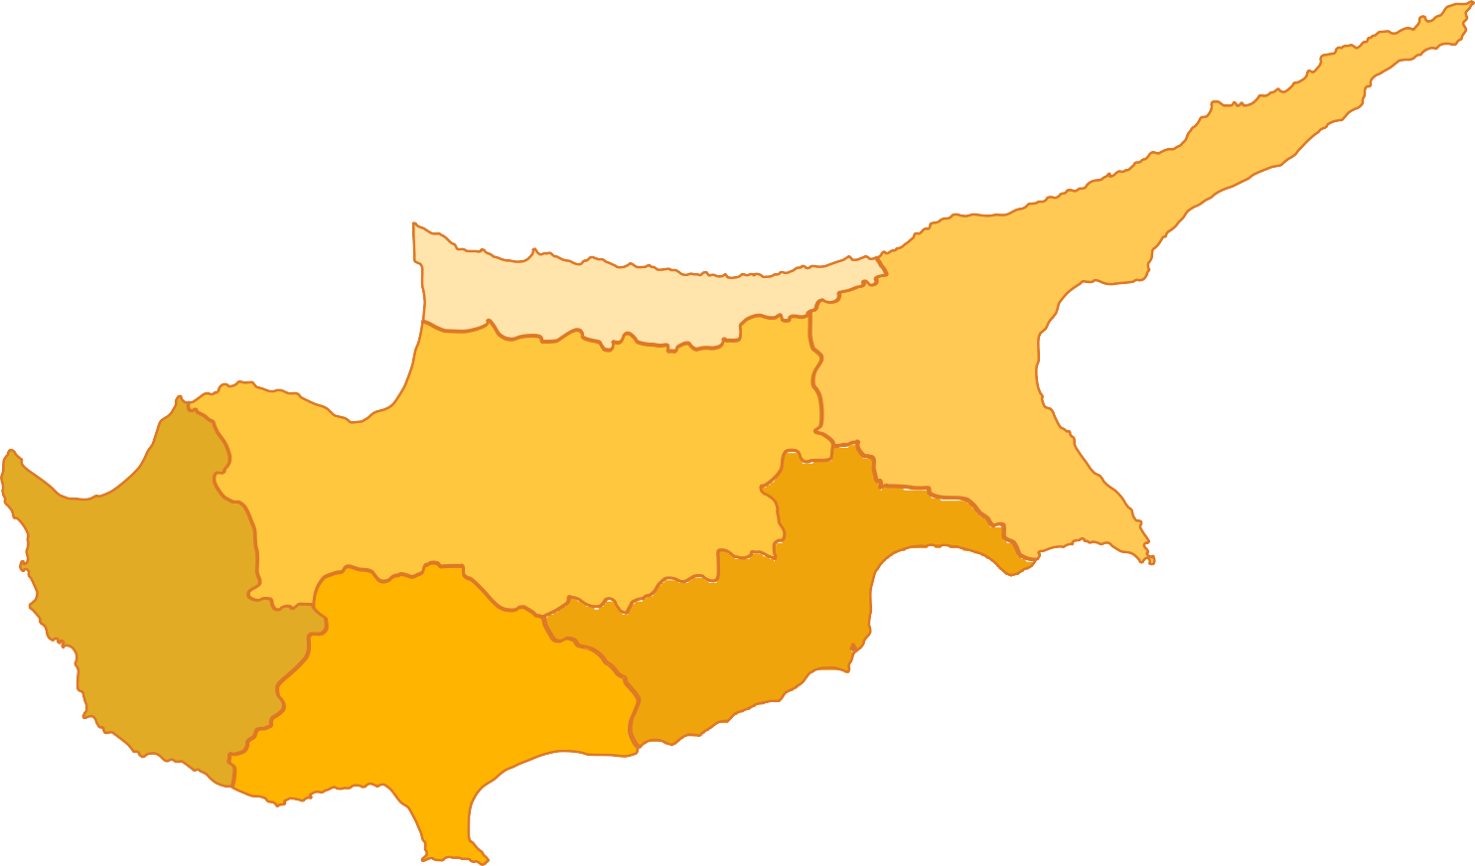

Paphos

###### Larnaca

District Snapshots

Limassol

PwC Cyprus Real Estate

18

Interactive map



**Nicosia Snapshot**

**(3%)**

YoY drop in #

**#6.000**

2023

YoY drop in €

2023

**€1,0bn (1%)**



**Apartments**

€ transaction value # properties

Average price per unit

2022

2023

Trend (2023 Vs 2022)

€396mln €437mln #2.440 #2.500

€162k €175k

|  |  |
| --- | --- |
| **Houses** | 2022 2023 Trend  (2023 Vs 2022) |
| € transaction value | €232mln €203mln |
| # properties | #990 #840 |
| Average price per uni t | €234k €242k |

|  |  |
| --- | --- |
| **Land Fields** | 2022 2023 Trend  (2023 Vs 2022) |
| € transaction value | €92mln €89mln |
| # properties | #1.410 #1.390 |
| Average price per unit | €65k €64k |

|  |  |
| --- | --- |
| **Land Plots** | 2022 2023 Trend  (2023 Vs 2022) |
| € transaction value | €154mln €157mln |
| # properties | #910 #890 |
| Average price per uni t | €169k €176k |

**Source**: Department of Lands and Surveys (DLS), PwC Analysis

PwC Cyprus Real Estate

19

**real estate transactions in Nicosia recorded through the DLS during 2023**

**Top 5**

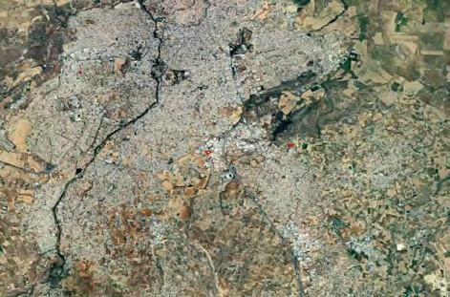

5

4

2

1

3

March 2023

**2**

Latsia Municipality

June 2023

**3**

Idalio Municipality

May 2023

**4**

Strovolos Municipality

October 2023

**5**

Engomi Municipality

Residential

Commercial

Commercial

Residential

House

Industrial unit

Industrial unit

Apartment Block

House situated within a plot of land with total surface area of c. 6.700m2

Industrial building under construction

**1**

September 2023

Commercial

Mixed-use building

Mixed-use building under construction

€4,7mln

Latsia Municipality

**Transaction**

**Price (€)**

**Description**

**Property Type**

**Property Category**

**Transaction date**

Industrial unit situated in Strovolos industrial area

Off-plan residential apartment block being developed on a plot of land of c. 775m2, in

€4,5mln

€4,0mln

€3,2mln

€3,1mln

**Note**: In relation to the transaction prices presented above, in the case where the Declared price and the Accepted

price (by the DLS) vary, for the purposes of this analysis the average of the two was indicatively adopted.

Engomi Municipality

PwC Cyprus Real Estate

20

Interactive map

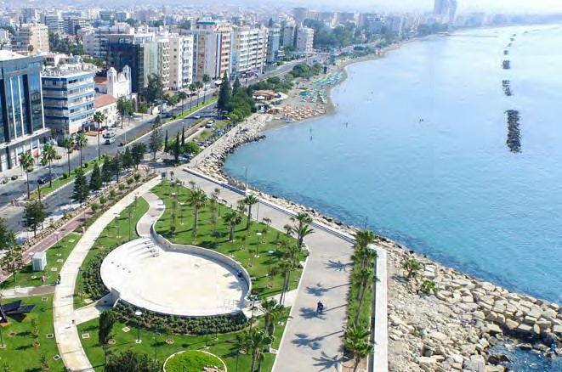

**Limassol Snapshot**

**(3%)**

YoY drop in #

**#7.150**

2023

YoY drop in €

2023

**€2,3bn (8%)**



€390k

€422k

Average price per unit

#3.010 #2.730

# properties

€1.270mln €1.065mln

€ transaction value

Trend (2023 Vs 2022)

2023

2022

**Apartments**

|  |  |  |
| --- | --- | --- |
| **Houses** |  | 2022 2023 Trend  (2023 Vs 2022) |
| € transaction value | €527mln €559mln | |
| # properties | #1.390 #1.320 | |
| Average price per unit | €379k €423k | |

|  |  |  |  |  |
| --- | --- | --- | --- | --- |
| **Land Fields** |  | 2022 | 2023 | Trend (2023 Vs 2022) |
| € transaction value |  | €276mln | €270mln |  |
| # properties  Average price per unit |  | #1.740  €158k | #1.900  €142k |  |

|  |  |  |  |
| --- | --- | --- | --- |
| **Land Plots** | 2022 | 2023 | Trend (2023 Vs 2022) |
| € transaction value | €238mln | €253mln |  |
| # properties  Average price per unit | #890  €267k | #860  €295k |  |

**Source**: Department of Lands and Surveys (DLS), PwC Analysis



PwC Cyprus Real Estate

21

##### real estate transactions in Limassol recorded through the DLS during 2023

5

4 2

1

3

**Top 5**

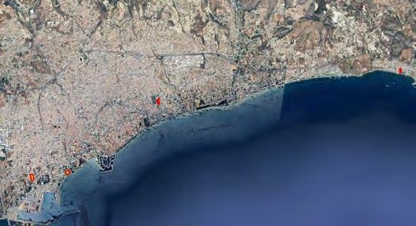

5

3

2

4

1

September 2023

**2**

Limassol Municipality

Agios Ioannis

May 2023

**3**

Limassol Municipality

Agios Nikolaos

July 2023

**4**

Limassol Municipality

Zakaki

April 2023

**5**

Parekklisia

Residential

Land

Land

Residential

Residential project

Field

Field

Apartment

Residential project comprising 5 apartment blocks situated in Ayios Ioannis Quarter

Field with a total surface of c. 10.850m² situated along Griva Digeni Avenue.

March 2023

Land

Fields

8 adjacent parcels of land situated along the coast, near the Limassol port area

€24,2mln

Limassol Municipality

Tsiflikoudia

**1**

**Transaction**

**Price (€)**

**Description**

**Property Type**

**Property Category**

**Transaction date**

The field is situated within residential

and commercial planning zones

Field with a total surface of c.22.400m² located in the new port area of Limassol. The field is situated within residential and commercial planning zones

3-bed apartment on the 5th floor of a newly constructed coastal residential project

€13,2mln

€12,0mln

€12,0mln

€10,3mln

**Note**: In relation to the transaction prices presented above, in the case where the Declared price and the Accepted price (by the DLS) vary, for the purposes of this analysis the average of the two was indicatively adopted.

PwC Cyprus Real Estate

22

Interactive map



**Larnaca Snapshot**

**20%**

YoY increase in €

**#5.240**

2023

YoY increase in €

2023

**€896mln 22%**



**Apartments**

€ transaction value # properties

Average price per unit

2022

2023

Trend (2023 Vs 2022)

€277mln €359mln #1.920 #2.300

€144k €156k

|  |  |
| --- | --- |
| **Houses** | 2022 2023 Trend  (2023 Vs 2022) |
| € transaction value | €178mln €236mln |
| # properties | #850 #920 |
| Average price per unit | €210k €257k |

|  |  |  |  |
| --- | --- | --- | --- |
| **Land Fields** | 2022 | 2023 | Trend (2023 Vs 2022) |
| € transaction value | €71mln | €127mln |  |
| # properties  Average price per unit | #710  €99k | #1.020  €125k |  |

|  |  |
| --- | --- |
| **Land Plots** | 2022 2023 Trend  (2023 Vs 2022) |
| € transaction value | €90mln €120mln |
| # properties | #590 #750 |
| Average price per unit | €152k €160k |

**Source**: Department of Lands and Surveys (DLS), PwC Analysis



PwC Cyprus Real Estate

23

##### real estate transactions in Larnaca recorded through the DLS during 2023

5

4 2

1

3

**Top 5**

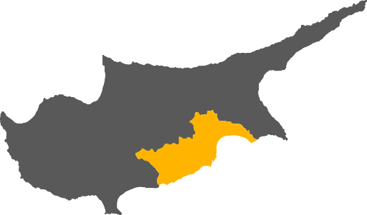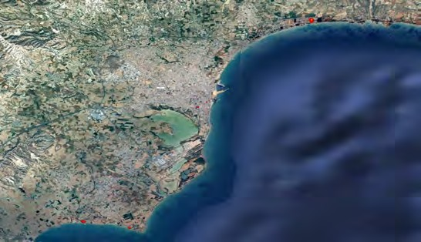

1

2

4

5

3

June 2023

**2**

Larnaca Municipality

City Center

July 2023

**3**

Perivolia

August 2023

**4**

Larnaca Municipality

Coast

June 2023

**5**

Perivolia

Land

Land

Hospitality

Land

Plot

Plot

Hotel

Plot

Plot of land with an area of c.6.000m², situated within residential and commercial planning zones

Seafront plot of land within a tourist planning zone, with an area of c.9.000m2

**1**

January 2023

Land

Field

Field with a total surface of 38.000m² within tourist planning zone, located c.100m from the sea

€8,9mln

Pyla

**Transaction**

**Price (€)**

**Description**

**Property Type**

**Property Category**

**Transaction date**

2-star hotel with a capacity of 40 rooms, situated in the Larnaca city-centre

Plot of land with an area of c.20.000m2, located c.50m from the sea. The plot is situated within a tourist planning zone

€6,8mln

€3,8mln

€3,8mln

€3,7mln

**Note**: In relation to the transaction prices presented above, in the case where the Declared price and the Accepted price (by the DLS) vary, for the purposes of this analysis the average of the two was indicatively adopted.

PwC Cyprus Real Estate

24

Interactive map

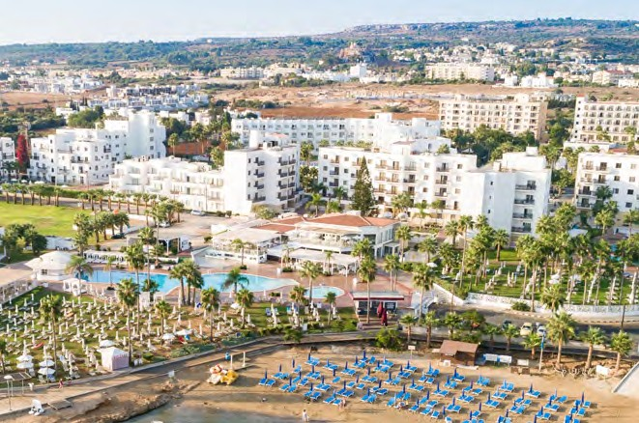

**Famagusta Snapshot**

**(1%)**

YoY drop in #

**#1.320**

2023

YoY drop in €

2023

**€253mln (3%)**



**Apartments**

€ transaction value # properties

Average price per unit

2022

2023

Trend (2023 Vs 2022)

€70mln €61mln

#470 #440

€148k €140k

|  |  |
| --- | --- |
| **Houses** | 2022 2023 Trend  (2023 Vs 2022) |
| € transaction value | €129mln €108mln |
| # properties | #400 #390 |
| Average price per unit | €324k €276k |

|  |  |
| --- | --- |
| **Land Fields** | 2022 2023 Trend  (2023 Vs 2022) |
| € transaction value | €34mln €42mln |
| # properties | #280 #300 |
| Average price per unit | €123k €139k |

|  |  |  |  |
| --- | --- | --- | --- |
| **Land Plots** | 2022 | 2023 | Trend (2023 Vs 2022) |
| € transaction value  # properties | €10mln  #90 | €15mln  #110 |  |
| Average price per unit | €112k | €133k |  |

**Source**: Department of Lands and Surveys (DLS), PwC Analysis



PwC Cyprus Real Estate

25

##### real estate transactions in Famagusta recorded through the DLS during 2023

**Top 5**

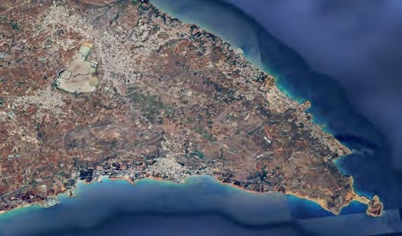

3

4

5

1

2

February 2023

**2**

Ayia Napa Municipality

Coast

Residential

**3**

Paralimni Municipality

Centre

Villa

Seafront 5-bedroom villa situated in Ayia Napa

Commercial building (incl. offices

**1**

August 2023

Land

Field

Seafront field with a total area of c.28.000m², situated within tourist planning zone

€9,1mln

Paralimni Municipality

Coast

**Transaction**

**Price (€)**

**Description**

**Property Type**

**Property Category**

**Transaction date**

|  |  |  |  |  |
| --- | --- | --- | --- | --- |
| November 2023 | Commercial | Commercial buildin | g and retail spaces) with a total surface Protaras Avenue | €4,8mln |
| April 2023 | Land | Field | Seafront field covering an area of c.12.000m², situated within a touristic planning zone | €3,8mln |
| January 2023 | Residential | Apartment | 6-bedroom penthouse on the 5th floor of a newly constructed coastal residential project | €2,6mln |

area of c.2.700m2 situated along

€5,5mln

**4**

Paralimni Municipality

Coast

**5**

Paralimni Municipality

Coast

**Note**: In relation to the transaction prices presented above, in the case where the Declared price and the Accepted price (by the DLS) vary, for the purposes of this analysis the average of the two was indicatively adopted.

PwC Cyprus Real Estate

26

Interactive map



**Paphos Snapshot**

**3%**

YoY increase in €

**# 4.430**

2023

**4%**

YoY increase in €

**€1,1bn**

2023



**Apartments**

€ transaction value # properties

Average price per unit

2022

2023

Trend (2023 Vs 2022)

€259mln €294mln #1.610 #1.640

€161k €179k

|  |  |  |  |
| --- | --- | --- | --- |
| **Houses** | 2022 | 2023 | Trend (2023 Vs 2022) |
| € transaction value | €550mln | €529mln |  |
| # properties  Average price per unit | #1.500  €366k | #1.470  €360k |  |

|  |  |
| --- | --- |
| **Land Fields** | 2022 2023 Trend  (2023 Vs 2022) |
| € transaction value | €128mln €119mln |
| # properties | #740 #770 |
| Average price per unit | €172k €155k |

|  |  |
| --- | --- |
| **Land Plots** | 2022 2023 Trend  (2023 Vs 2022) |
| € transaction value | €55mln €82mln |
| # properties | #270 #320 |
| Average price per unit | €202k €255k |

**Source**: Department of Lands and Surveys (DLS), PwC Analysis

PwC Cyprus Real Estate

27

##### real estate transactions in Paphos recorded through the DLS during 2023

**Top 5**

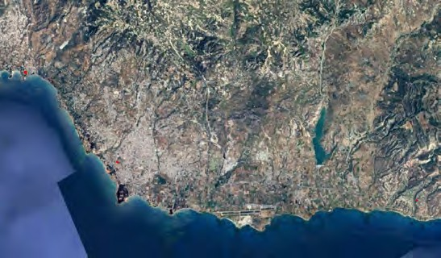

4

1

3

5

2

March 2023

**2**

Kouklia

October 2023

**3**

Tsada

June 2023

**4**

Pegeia Municipality

April 2023

**5**

Paphos Municipality

Residential

Residential

Land

Land

Villa

Villa

Field

Field

Villa situated within an integrated golf project

Villa situated within an integrated golf project

March 2023

Residential

Villa

Villa situated within an integrated golf project

€8,4mln

Tsada

**1**

**Transaction**

**Price (€)**

**Description**

**Property Type**

**Property Category**

**Transaction date**

Field with a total area of c16.000m² situated in close proximity to Coral Bay. The field falls within a tourist planning zone

Field with a total area of c.7.300m² within a residential planning zone. The property is situated in close proximity to the archeological site of the Tombs of the Kings

€5,0mln

€4,1mln

€3,9mln

€3,5mln

**Note**: In relation to the transaction prices presented above, in the case where the Declared price and the Accepted

price (by the DLS) vary, for the purposes of this analysis the average of the two was indicatively adopted.

PwC Cyprus Real Estate

28

**Transaction value by type**

During 2023, the transaction value of the residential property sector reached c.€3,9bn representing a YoY decrease of c.1%. According to PwC analysis, in total c.14.600 apartments and houses were sold (c.9.600 apartments and c.5.000 houses), recording a mere increase of 0,3%. The residential property sector made up 69% of the total value of transactions in the sector during the year (40% apartments and 29% houses), compared to a 70% contribution during 2022.



Apartments Houses Commercial Land

**Transaction value per month (2021 - 2023)**

3%

23%

40%

5%

***€***

29%

Average monthly transaction value Average monthly transaction value

Other

**Source**: Department of Lands and Surveys (DLS), PwC Analysis

700

~~2022: €461mln~~   ~~2023: €461mln~~

600

War in Ukraine

500

400

**Value (€mln)**

300

200

100

-

H1 2023: €492mln H2 2023: €431mln

Residential Commercial & Other Land

Israel-Hamas War

* The effects from the war in Ukraine further accelerated the materialisation of relocations of foreign operations and staff in Cyprus, leading to a relatively high average monthly transaction value of €460mln during 2022.
* The surging activity was sustained during the first half of 2023, with the average monthly value of transactions reaching c.€492mln. The market experienced a slowdown during the second half, highlighted by the final quarter

of the year, in the aftermath of the Israel-Hamas war and the sustained geopolitical instability effects. During the second half of

2023, average monthly transaction value stood at c.€431mln. Overall during the year, average monthly transactions stood at c.€461mln.

**Source**: Department of Lands and Surveys (DLS), PwC Analysis

29 PwC Cyprus Real Estate

Apartments sold per price bucket

Apartments

**2022**

**2023**

>1mln 500k-1mln 250k-500k

0-250k

|  |  |  |
| --- | --- | --- |
| € transaction value | €2,3bn | €2,2bn |
| # properties | 9.500 | 9.600 |
| Average price per unit | €240k | €231k |

226

175

467

455

1.495

1.709

6.700

6.937

- 1.000 2.000 3.000 4.000 5.000 6.000 7.000 8.000

2022 2023

Houses sold per price bucket



Houses

166

**2022**

|  |  |  |  |  |  |  |
| --- | --- | --- | --- | --- | --- | --- |
| - | 500 | 1.000 |  | 1.500 | 2.000 | 2.500 |
| **Source**: Department of Lands and Surveys (DLS), PwC Analysis  **Note**: The number of transactions included in the price bucket chart differ from the total transactions presented in the |  | 2022 | 2023 |  | | |
| table above, as the chart includes only single unit transactions with 100% share (to avoid statistical discrepancies). |  |  |  |

**2022**



Land Fields

**2023**

**2023**

>1mln 500k-1mln 250k-500k

0-250k

|  |  |  |
| --- | --- | --- |
| € transaction value | €1,6bn | €1,6bn |
| # properties | 5.100 | 4.900 |
| Average price per unit | €315k | €331k |

158

432

524

**2022**



Land Plots

**2023**

1.553

1.610

2.124

1.929

|  |  |  |
| --- | --- | --- |
| € transaction value | €0,60bn | €0,65bn |
| # properties | 4.900 | 5.400 |
| Average price per field | €123k | €120k |

|  |  |  |
| --- | --- | --- |
| € transaction value | €0,55bn | €0,63bn |
| # properties | 2.800 | 2.900 |
| Average price per plot | €199k | €214k |

**Source**: Department of Lands and Surveys (DLS), PwC Analysis



PwC Cyprus Real Estate

30

**Land transactions by planning zone**

Land transactions reached €1,3bn during 2023, representing an increase of 11% compared to 2022. Overall, land transactions made up 23% of the total transaction value of the sector and 34% of the total volume of transactions of the sector.

68% of land transactions in terms of value, relate to properties situated within residential planning zones, whereas 13% comprised land within agricultural planning zones. In volume terms, 53% comprised land within residential planning zones and 40% comprised land within agricultural planning zones.

Transaction value by planning zone (2023) Transaction volume by planning zone (2023)

1% 2% 2% 2%

1%

10%

4%

4%

13%

### € #

40%



53%

68%

Agricultural Residential Commercial & Special Zones Industrial Tourist Other / Non-identified

**Source:** Department of Lands and Surveys (DLS), PwC Analysis

31 PwC Cyprus Real Estate

**2023 Growth**

**per property type**

Change in volume of transactions (2023 Vs 2022)



23.600 686 154 (5)

**# properties transacted**

(102)

(182) 24.151

2022 Land Apartments Commercial Other/ Houses 2023

Other



The marginal drop in value of apartment transactions recorded during the year, appears to have been offset by a notable growth in land transactions and particularly residential land plots.

Unidentified

Change in value of transactions (2023 Vs 2022)

€5.549 €126 €19 (€2) (€54) (€91) €5.548

**€mln value of properties transacted**

2022

Land

Houses Commercial Apartments

Other/

Unidentified

2023

**Source**: Department of Lands and Surveys (DLS), PwC Analysis

Other

PwC Cyprus Real Estate

32

Foreign transaction activity

During 2023, a total of 6.900 properties across Cyprus were acquired by foreigners (in terms of sale contracts filed at the DLS) compared to 5.928 properties during 2022, representing

No. of properties acquired by foreigners based on sale contracts

**filed at the DLS (2019-2023)**

8.000

a 16% increase. Foreign activity patterns

|  |  |  |
| --- | --- | --- |
| appear correlated with the continued influx of |  |  |
| foreign companies relocating their operations  and staff on the island, albeit at a slower rate | 6.000 |
| compared to last year. | 5.000 | **4.481** |
| All Cyprus districts (except Famagusta) | 4.000 |  |

7.000

**6.900**

recorded YoY increases during 2023, in terms of the number of properties acquired by foreigners (based on sale contracts filed at the DLS). Larnaca experienced the most

significant increase (25%), followed by Nicosia

(21%) and Limassol (16%).

3.000

2.000

1.000

-

2019



**5.928**

**3.691**

**2.985**

2020

2021

2022

2023



**No. of properties acquired by foreigners per district based on sale contracts filed at the DLS (2022 - 2023)**

%

change

21%

16%

25%

(6%)

15%

2.500

2.320

2.350

2.006

2.044

2.000

1.473

1.500

1.178

1.000

500

364

440

336

317

-

Nicosia

Limassol

**Source**: Department of Lands and Surveys (DLS), PwC Analysis

Larnaca

2022 2023

Famagusta

Paphos

33 PwC Cyprus Real Estate

The highest concentration of sale contracts filed by foreign buyers took place at the districts of Limassol and Paphos (34% respectively).The two coastal districts together make up more than two thirds of foreign transactions on the island.

Geographical distribution of properties acquired by foreigners based

**on sale contracts filed (2023)**

Looking at the monthly data, it is evident that the number of properties acquired by foreigners outnumbered each respective month of 2022 with the exception of November and December 2023, which

**34%**

**6%**

**Nicos**

21%

**5%**

**Famagusta**

experienced decreases of 16% and 18% respectively, which appears to be largely attributable to the outbreak of the

Israel-Hamas war in early October.

Approximately 72% of properties acquired by foreigners during 2023 relate to non-EU buyers (2022: 57%). Limassol represented the district with the highest proportion of non-EU buyers (77%), followed by Larnaca (74%) and Paphos (70%).

Paphos

The image part with relationship ID rId7 was not found in the file.

34%

**ia**

**Nicosia**

Larnaca

**Limassol**

No. of properties acquired by foreigners based on sale contracts filed at the DLS per month (2022 - 2023)

Outbreak of Israel-Hamas war

700

600

500

400

594

400 413

475

464

637

370

556

508

660 655

473

515

615

435

493

556

604

506

643 645

550 538 523

300

200

100

-

Jan

Feb

Mar

Apr

May

Jun

Jul

Aug

Sep

Oct

Nov

Dec

**Source:** Department of Lands and Surveys (DLS), PwC Analysis

2022 2023

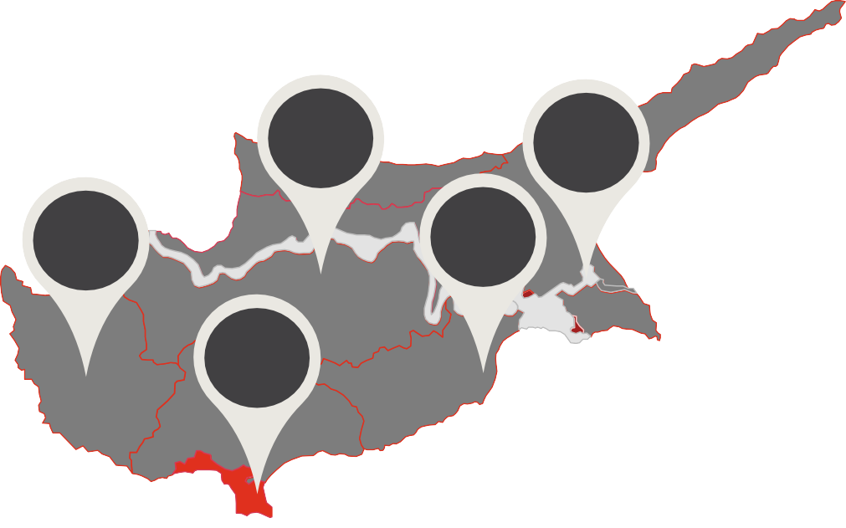

34 PwC Cyprus Real Estate

**2023 Growth of foreign transaction activity per district**

Change in volume of properties transacted (2023 Vs 2022)

% of growth

32% 32%

30% 8%

(2%)

5.928

**# of properties transacted**

314 306

295 76 (19) 6.900



2022 Limassol Paphos Larnaca Nicosia Famagusta 2023

**Source**: Department of Lands and Surveys (DLS), PwC Analysis

1. PwC Cyprus Real Estate



1. PwC Cyprus Real Estate

## High-end residential property

segment (≥ €1,5mln)

The high-end residential property segment appears to be shrinking in 2023, with

the analysis of transaction data of single residential properties with a price of ≥€1,5mln, indicating a YoY drop of 26%. The data suggests that during the year a total of 164 transactions were recorded in this segment

of the market, with total values reaching

€440mln.

The size of this segment during 2023 appears halved when compared to the peak 2017 – 2018 activity and has subsided to the levels observed during the Covid-19 period. Overall, the high-end property sector (≥ €1,5mln) contributed c.8% of the total transaction value of the sector during 2023, representing the lowest contribution since 2013.

**Volume and Value of high-end properties transacted (≥€1,5mln)**

900

800

**€mln value of properties transacted**

700

600

500

400

300

200

100

72

27 €190mln

106

€280mln

215

€570mln

317 324 318

€800mln €810mln

€720mln

177

€400mln

162

€440mln

221

€610mln

**8%**

of total sector transaction value

164

€440mln

350

300

250

**# properties transacted**

200

150

100

50

-

€80mln

2013

2014

2015

2016

2017

2018

2019

2020

2021

2022

0

2023



Transaction value (€mln) No. of properties transacted

**Source**: Department of Lands and Surveys (DLS), PwC Analysis

**Note**: High-end residential property segment statistics for all years were based on a data extraction dated 31/01/2024. Any differences with previous publications

relate to amended Land Registry records (e.g. cancellations of previous sales etc.) and discrepancies between the date of agreement and respective filing date.

1. PwC Cyprus Real Estate

Limassol district continues to dominate the share of high-end residential property transactions (74% during 2023), followed by Paphos with 15% of the share. The two coastal districts make up 89% of the size of this segment (2022: 93%).

3%

17%

3%

1%

5%

15%

2%

4%

#### 2022 2023

76%

74%

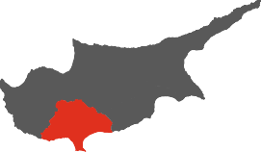

Nicosia Limassol Larnaca Famagusta Paphos

**Source**: Department of Lands and Surveys (DLS), PwC Analysis

**Note**: The PwC Analysis has been based on transaction data by the DLS in a digital format, extracted from the DLS Portal on 31/01/2024 and relate to transactions with an agreement date up to 31/12/2023.

1. PwC Cyprus Real Estate

## Real estate price evolution

Residential Property Prices

The behaviour of residential property prices across Cyprus is captured by the Central Bank of Cyprus (CBC) index, amongst other publicly available indices. During 2022, residential property index prices recorded a 7% annual growth, mainly driven by domestic housing demand and rising construction costs. Up to Q3 2023 (being the latest available information) residential property index prices maintained their increasing trend, marking a c.8% YoY increase and a c.6% compared to Q4 2022. The increase in index prices is partially attributed to the sustained levels of domestic housing demand, the effects of rising construction costs in previous periods and surging levels of demand from foreign buyers.

CBC Residential Property Price Index (2010 - Q3 2023)

105

100

95

Period of Decline / Correction of Prices Price

Stabilisation

Period of Growth

QoQ % change (Q1 22 – Q3 23)

90

85

1,11%

80

75

70

1,59%

2,16%

2,09%

1,53%

1,48%

2,24%

65

60

2010 2011 2012 2013 2014

2015 2016

2017 2018 2019 2020 2021 2022 Q3 2023

Q1

2022

Q2

2022

Q3

2022

Q4

2022

Q1

2023

Q2

2023

Q3

2023



**Annual price change**

**2011**

**2012 2013 2014 2015 2016 2017 2018 2019 2020 2021 2022 12 Months ending**

**Q3 2023 (YoY%)**

CBC

(5%) (5%) (9%) (8%) (2%) (1%) 2% 3% 2% 1% 3%

7%

8%

**Source:** CBC RPPI, PwC Analysis

1. PwC Cyprus Real Estate

Based on the CBC price index on an annual basis up to Q3 2023, residential property prices in all Cyprus districts, recorded increases, with the most significant index movements being recorded in Larnaca (11%) and Limassol (10%).

YoY % growth in CBC Residential Property Price Index

**(Q3 2023 Vs Q3 2022)**

**4% 6%**

**8% Nicos**

**11%**

Famagusta

The image part with relationship ID rId7 was not found in the file.

**ia**

**Nicosia**

**Paphos**

**10%**

**Larnaca**

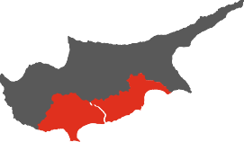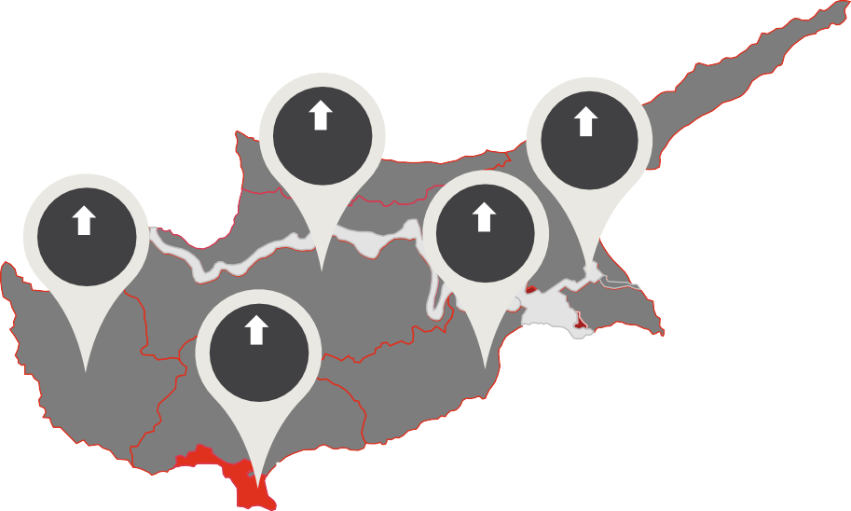

Limassol

**Source**: CBC RPPI, PwC Analysis

1. PwC Cyprus Real Estate

Construction activity

New building permits issued during the period January - October 2023 (10M 2023) stood at 5.906, representing an annual drop of 7%. In value terms, the new permits issued increased by 17% compared to 10M 2022 which is mainly attributed to the development of larger scale infrastructure projects by the private sector.

According to the latest EC report (Autumn 2023), a slowdown in residential construction activity is expected in the coming years, following the robust expansion of the sector during the last years, coupled with a sustained environment of increased interest rates.

Building permits number Vs value (€mln)

10.000

4000

9.000

8.000

8.777

7.506 7.172

7.218

8.164

7.023

3.729

7.604

3000

**Value of permits (€mln)**

7.000

**No. of permits**

6.000

5.000

2.640

2.065

5.341

4.933 5.014

5.354 5.728

6.408

2.055

2.710

2.498

2.497

5.906

2.409

2000

4.000

3.000

2.000

1.000

-

1.632

1.141

859

1.071

1.158

1.720

1000

0

2010 2011 2012 2013 2014 2015 2016 2017 2018 2019 2020 2021 2022

Number of permits Value of permits (€mln)

10M 2023

Building permits number Vs value (10M 2022 - 10M 2023)

2.409

**10M 2023 Vs 10M 2022**

8.000

**Value of permits (€mln)**

7.000

**No. of permits**

6.000

5.000

4.000

3.000

2.000

2.059

6.347

5.906

2.500

2.000

1.500

1.000

500

-

# (7%)

Decrease in #

# 17%

10M 2022 10M 2023

Number of permits Value of permits (€mln)

**Source:** Cystat, PwC Analysis

Increase in €

1. PwC Cyprus Real Estate

##### Distribution of building permits

**per district and surface (m²)**

The largest concentration of new permits for developments, in terms of licensed building surface (m²) during 10M 2023, relates to

**10M 2022 10M 2023**

Nicosia (39%) and is followed by Limassol (33%).

During 10M 2023, Larnaca and Paphos witnessed YoY decreases of 23% and 16% respectively, which may be attributed to the rapid expansion in activity observed in the previous year. On the other hand, the surface being licensed for development continues to grow in Nicosia and Limassol, both recording a 4% increase on a YoY basis.

4%

15%

13%

Surface area (m²) licensed by district

31%

37%

3%

14%

11%

Surface area (m²) licensed by district

33%

39%

Nicosia Limassol Larnaca Famagusta Paphos

**Surface area licensed (m²) per district (10M 2022 - 10M 2023)**

800.000

700.000

733.273

600.000

670.028

626.508

500.000

569.320

400.000

300.000

200.000

266.771

257.813

74.826

56.880

231.853

100.000

202.687

-

Nicosia

Limassol

Larnaca

Famagusta

Paphos

**Source:** Cystat, PwC Analysis

10M 2022 10M 2023



1. PwC Cyprus Real Estate

Overall, residential developments constituted the majority of licensed surface area during 10M 2023, making up 85% of new developments licensed. The residential sector demonstrated a 7% increase

in licensed surface during 10M 2023 compared to the respective period in 2022.

Surface area (m²) licensed for non- residential buildings experienced a drop of 11% compared to the respective period in 2022.

Noteworthy is the decline in the number

of office and hotel & leisure developments licensed during 10M 2023, which recorded a 38% and 66% decrease respectively.

Licensed surface area (m2) by category

1.800.000



7%

67%

(5%)

(38%)

(66%)

5%

1.600.000

1.400.000

1.200.000

1.000.000

800.000

600.000

400.000

200.000

-

Residential Other Warehouses Offices Hotel and



**10M 2022**

17%

Surface area (m²) licensed

83%

Leisure

Retail

**Source:** Cystat, PwC Analysis 10M 2022 10M 2023

Breakdown of non-residential surface area (m²) (10M 2023 Vs 10M 2022)

**10M 2023**

Other*

Offices

15%

Surface area (m²) licensed

85%

**10M 2022**

**10M 2023**

Retail

Warehouses

28%

3%

25%

22%

22%

20%

4%

26%

42%

Residential Non-Residential

Hotel & Leisure

**Source:** Cystat, PwC Analysis

8%

**Source:** Cystat, PwC Analysis

**Note:** Other relates to (i) public entertainment buildings and buildings used for recreational, educational or medical purposes, (ii) transport and communication buildings, and (iii) other non-residential buildings.

PwC Cyprus Real Estate

43

**Construction material prices during 2023**

The index of construction materials published by Cystat, appears to have decelerated during the year, recording a 3% growth (compared to 17% during 2022). The cost of minerals and mineral products seem to be the key drivers of the overall increase in costs (18,5% and 9,4% increase respectively), while the cost of metallic products appears to have subsided by 6,3% during the year (following a 23,7% increase in 2022).



|  |  |
| --- | --- |
| **Annual price change** | **2023** |
| Minerals | 18,5% |
| Products of wood, insulation materials, chemicals and plastics | 3,5% |
| Mineral products | 9,4% |
| Metallic products | (6,3%) |
| Electromechanical products | 2,7% |
| **Weighted** | **2,9%** |

% change in construction price material index (2010 - 2023)

17%

11%

4%

3%

1% 1%

3%

2%

0,3% 1%

(0,4%)

(2%) (2%)

(0,4%)



44 PwC Cyprus Real Estate

2009 2010 2011 2012 2013 2014 2015 2016 2017 2018 2019 2020 2021 2022 2023

**Source:** Cystat, PwC Analysis

How PwC can help



At PwC Cyprus, we have a truly dedicated and integrated team specialising in the real estate sector. Our team takes your whole business into account and focuses on your needs and objectives.

We are uniquely positioned to bring the best business advice with the best real estate advice, providing tailor-made solutions of high quality for specific needs to clients who develop, invest, own, lease, dispose or acquire any type of property in Cyprus.

We have a diverse team of real estate advisory experts with backgrounds ranging from transaction specialists, management consultants, property valuers, planning experts and finance experts. We are as comfortable in talking business, finance and tax, as we are with development designs, town planning permits, Land Registry procedures and site plans, bringing a whole different approach to real estate.

Combined with our strong international network, we are able to offer turn-key solutions in support of our clients’ needs in all their countries of operation. Whether a private land owner, a financial institution, a real estate developer, a corporate occupier or a real estate investment fund, we can help you turn real estate into real outcomes.

Our clients draw comfort from working with PwC, the leading organisation of its kind in the world, and from the integrity, reliability and security that brings with it.

45 PwC Cyprus Real Estate

##### What we bring to our clients

**Diverse team of real estate advisory experts** with backgrounds ranging from transaction specialists, management consultants, property valuers, planning experts and finance experts

Unparalleled track record in **property transaction advisory services**

In-depth **understanding of the changing market forces** that are affecting the local real estate industry

**Ongoing monitoring**

of the behaviour of the market and its dynamics through advanced analytics of transaction data

Regularly updated **own- database of property transactions**

Industry-focused expertise in the formulation of **real estate asset management strategies** and **project conceptualisations**

A strong **reputation for rigour, independence and impartiality**

Extensive experience of qualitative and quantitative **research techniques for real estate transaction activity**

PwC Cyprus Real Estate

46

**In-depth knowledge** of Town Planning Regulations and Land Registry workings

PwC Real Estate Advisory Services

##### Real estate transaction advisory services

* M&A advisory and assistance in raising finance
* Transaction support services



•

•

**Real**

* Go to market strategies
* Real Estate Due Diligence

##### Real estate data analytics & market analysis

* Benchmarking analysis Market intelligence

Real estate portfolio analytics

##### Valuation analysis &

**verification**

* + Valuation reviews for financial reporting

purposes

* + Property portfolio valuation analysis

##### estate development advisory

* + Development appraisals / Feasibility studies
  + Highest & Best Use analysis
  + Objective assessment of Business Plans
  + Financial modelling

PwC Cyprus Real Estate

47



48 PwC Cyprus Real Estate

PwC in Cyprus



In a world that is constantly evolving, our aim at PwC Cyprus is to find the right solutions to complex problems, creating value for our clients, stakeholders and society. We embrace the future with a focus on quality and by building strong relationships based on trust. In times of great challenge, trust is more important than ever. PwC’s new global strategy, “The New Equation”, leads to a people led and tech powered future. It includes our ability to look

at problems from different angles and present innovative solutions that make a difference and lead to sustained outcomes.

More than 1100 people in Cyprus join forces with 364,000 professionals of our global network in 151 countries and create an experienced team that combines intelligent approaches, experience and technological innovation.

In a dynamic and challenging business environment, where competition is more intense than ever, we are here to support you at every step of your journey. Ready to provide you with a broad range of services that meet even your most complex needs.

**Tax & Legal**

**Advisory**

**Assurance**

**Getting closer to our clients, understanding their business needs, working with**

**Tax & Finance Managed Services**

**them efficiently and supporting them to effectively address the challenges.**

Financial Services Funds

Our industry specialisation in the following sectors, gives you the benefit of our in-depth industry knowledge and experience.

Energy

CySEC Regulated Investment Firms Telecommunications & Technology Transportation & Logistics

Health

Banking

Real Estate & Construction Retail & Consumer Insurance

Hospitality & Leisure Government & Public Services

49

##### Your contacts for Real Estate matters

Constantinos Constantinou

Partner

Advisory, Real Estate Industry Leader T: +357 - 22 555 700

[constantinos.constantinou@pwc.com](mailto:constantinos.constantinou@pwc.com)

Constantinos Savvides

Director

In charge of Real Estate Advisory T: +357 - 22 555 503

[constantinos.savvides@pwc.com](mailto:constantinos.savvides@pwc.com)

**Nicosia**

PwC Central, 43 Demostheni Severi Avenue,

CY-1080 Nicosia

P O Box 21612, CY-1591

Nicosia, Cyprus

Tel: +357 - 22 555 000

**Limassol**

City House, 6 Karaiskakis Street, CY-3032 Limassol

P O Box 53034, CY-3300 Limassol, Cyprus Tel: +357 - 25 555 000

**Paphos**

2 Falirou Street,

CY-8035, Paphos

P O Box 60479, CY-8103 Paphos, Cyprus

Tel: +357 - 26 555 000

**Ioanna Charalambous**



Director

Real Estate Advisory T: +357 - 22 555 499

[ioanna.charalambous@pwc.com](mailto:ioanna.charalambous@pwc.com)

50 PwC Cyprus Real Estate



This content is for general information purposes only, and should not be used as a substitute for consultation with professional advisors. © 2024 PricewaterhouseCoopers Ltd. All rights reserved. PwC refers to the Cyprus member firm, and may sometimes refer to the PwC network. Each member firm is a separate legal entity.

Please see [www.pwc.com/structure](http://www.pwc.com/structure) for further details.